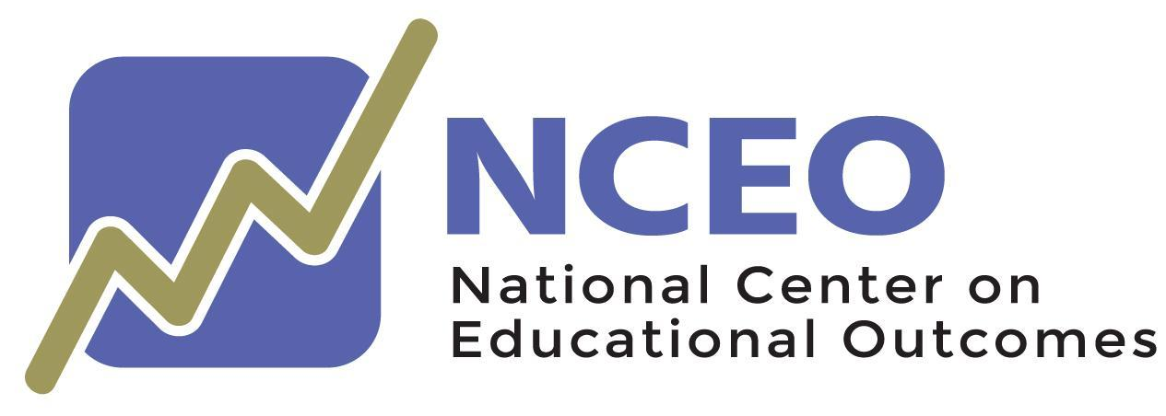

Communicating about Annual State Assessment Participation for All Students:
A Communication Toolkit

March 2023

Communicating about Annual State Assessment Participation for All Students: A Communication Toolkit

A publication of
NATIONAL CENTER ON EDUCATIONAL OUTCOMES

Andrew R. Hinkle, Eliana Tardio, Virginia A. Ressa, Sheryl S. Lazarus, Sylvia Kwon, Tiffany Katanyoutanant, Markie McNeilly, Bryan Hemberg, Kate Nagle, Kristin K. Liu, Kathy Strunk, and Martha L. Thurlow

The Center is supported through a Cooperative Agreement (#H326G210002) with the Research to Practice Division, Office of Special Education Programs, U.S. Department of Education. The Center is affiliated with the Institute on Community Integration at the College of Education and Human Development, University of Minnesota. Consistent with EDGAR §75.62, the contents of this report were developed under the Cooperative Agreement from the U.S. Department of Education, but do not necessarily represent the policy or opinions of the U.S. Department of Education or Offices within it. Readers should not assume endorsement by the federal government. Project Officer: David Egnor

All rights reserved. Any or all portions of this document may be reproduced and distributed without prior permission, provided the source is cited as:

Hinkle, A. R., Tardio, E., Ressa, V. A., Lazarus, S. S., Kwon, S., Katanyoutanant, T., McNeilly, M., Hemberg, B., Nagle, K., Liu, K. K., Strunk, K. & Thurlow, M. L. (2023). Communicating about annual state assessment participation for all students: A communication toolkit. National Center on Educational Outcomes.

This version of the Communication Toolkit is adapted from the 2021 publication of the same name with permission:

Kwon, S., Katanyoutanant, T., McNeilly, M., Hemberg, B., Nagle, K., Lazarus, S. S., Hinkle, A.R., Liu, K. K., Strunk, K. & Thurlow, M. L. (2021). Communicating about annual state assessment participation for all students: A communication toolkit. National Center on Educational Outcomes.

Table of Contents
Introduction 1
Family Letter 8
One-Page “ready-to-go” Flyers 9
Teacher One-Page “ready-to-go” Flyer 10
Policymaker One-Page “ready-to-go” Flyer 11
Families One-Page “ready-to-go” Flyer 12
Students One-Page “ready-to-go” Flyer 13
IEP Team One-Page Discussion Guide 14
Slide Presentation 16
Appendix A: Customizable Flyers 22
Teacher Customizable Flyer 23
Policymaker Customizable Flyer 26
Parent Customizable Flyer 29
Student Customizable Flyer 32
IEP Team Customizable Discussion Guide 35

Introduction

Although statewide testing requirements have been a feature of public K–12 education since the 1994 reauthorization of the Elementary and Secondary Education Act (Improving America’s Schools Act of 1994, 20 U.S.C. § 1111, 1994), questions about testing participation, such as “Why is it necessary for students to participate?” “Which students should participate?” “How does participation impact funding and decision making?” persist.

Purpose of Communications Toolkit
This communications toolkit was developed by the National Center on Educational Outcomes (NCEO) to identify and describe reasons why all students, including students with disabilities, English learners, and English learners with disabilities, should take state tests. The purpose of the tool is to provide a concise resource that state education agency staff and district and school administrators can use when communicating with educators, policymakers, families, and students about why it is so important that students participate in state assessments. It also contains materials that Individualized Education Program (IEP) teams can use when making state test participation decisions for students with disabilities. This toolkit is intended to provide a neutral but useful mechanism to guide positive, thoughtful conversations about student testing participation.

This toolkit includes:
- Sample social media posts
- Sample letter to families
- One-page “ready-to-go” flyers for educators, policymakers, families, and students
- One-page “ready-to-go” discussion guide flyer for IEP teams
- Customizable slide deck
- Appendix A: Customizable flyers for educators, policymakers, families, and students, and IEP team discussion guide

Please visit NCEO’s website https://nceo.info/ to access additional resources and tools related to state test participation and other assessment and educational outcome issues, such as supporting students with disabilities, English learners, and English learners with disabilities.

Social Media

Social media is a global dissemination tool used to amplify and maximize potential reach through the delivery of information in accessible and friendly ways that promote the inclusion of all interested parties. Social media users turn into followers when content is engaging, creative, and easy to digest. State education agencies, districts, and schools can use social media to build meaningful online communities that include families, educators, policymakers, and students.

Below are sample social media posts. Feel free to personalize or modify the examples to match your state’s, district’s, or school’s voice, style, and interests. Depending on the social media platform you will be using, the use of images and short videos will strengthen your message and provide opportunities to create meaningful and authentic connections with education partners.

Be sure to use customized hashtags in a consistent manner across the multiple social media platforms you use. Customized hashtags allow the user to search for all posts that have the same hashtag and also will allow you to look at performance metrics for the posts. Users are encouraged to use their own personalized hashtags to measure their own influence. For example, NCEO uses #NCEOInfo.

To access downloadable photos to use with social media posts, see https://nceo.umn.edu/docs/OnlinePubs/ParticipationCommunicationToolkit/CommunicationToolkitPhotos.docx. These photos can be freely used and do not need to be attributed.

*********
Sample Social Media Posts

General Posts

#StateTests are just one measure of #StudentProgress. In combination with other indicators, such as report cards, teacher feedback, and attendance, state tests contribute to a more complete picture about students’ #AcademicPerformance.

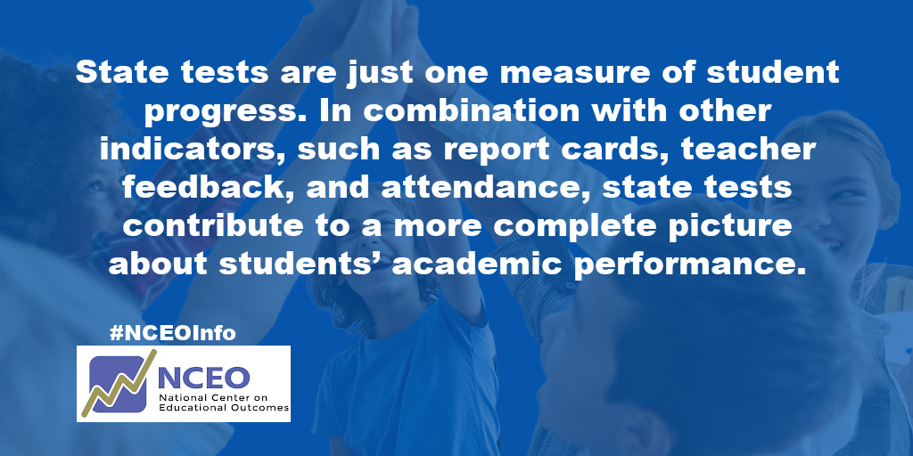

#StatewideTesting shows a snapshot of how a whole school system is performing, allowing for decisions that will improve programming and provide #TargetedResources and support to meet the needs of ALL students.

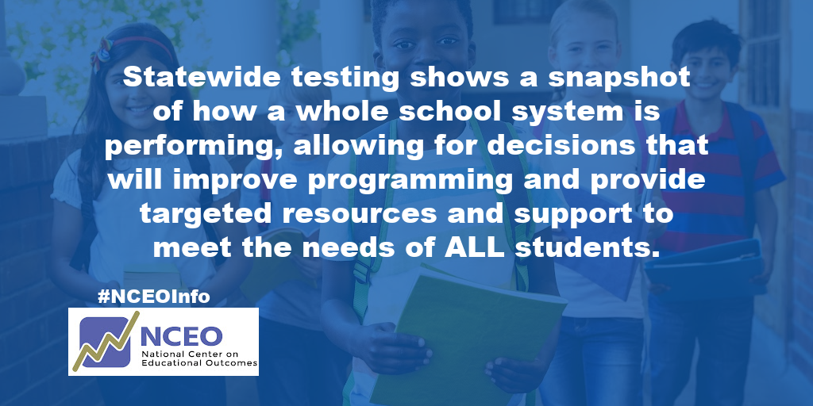

Why is #StateTesting important? Results help identify #LearningTrends. This is important if groups of students, such as #EnglishLanguageLearners, are being underserved.

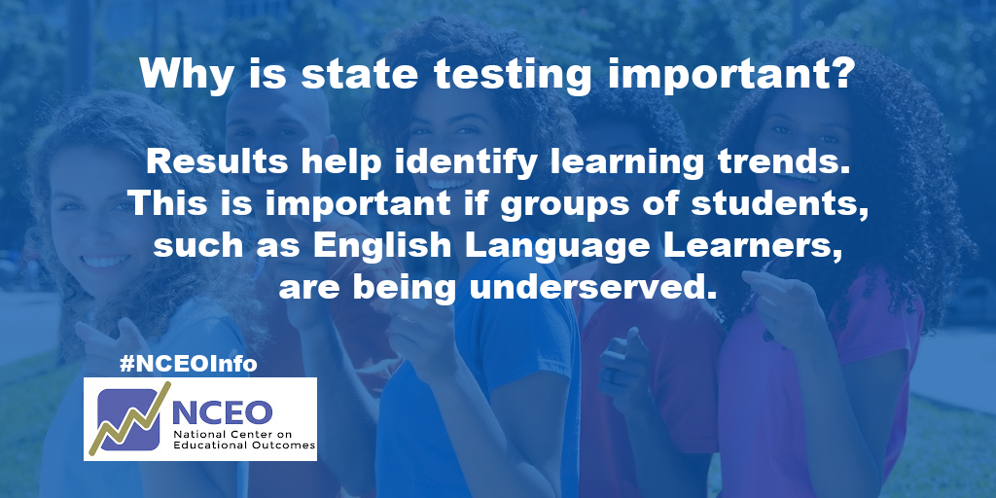

Posts aimed at Families

Provide #FamilySupport for students during #StateTesting. Remind your children that testing is a regular and important part of learning.

#StudentSupport from #Families during #StateTesting. Share your memories of state testing experiences with your children to help reduce their anxiety.

Your children need your #FamilySupport during #StateTesting. Tests are a way for students to show what they know and can do. Share your adult experiences with tests: #DriversExam #Credentialing #JobApplications

#FamilySupport during #StateTesting. Practice strategies to reduce #TestAnxiety (For example, breathing exercises, muscle relaxation, and stretching) before and during state testing.

Posts aimed at Students

#StateTesting preparation for #Students. What can help you during the test? A seat far from the window, repeated directions, wearing headphones? Share your ideas with parents & teachers.

#StateTesting helps #Students and their families assess progress toward completing high school and opportunities after high school (for example, attending college and being career ready).

4-day series of posts aimed at parents and families on why it is important for their child to take state tests

Day 1:
#StateTesting is coming. Join us to learn four reasons why #StatewideTesting is important for #AllStudents.

REASON 1: The test results provide information to families about how #LocalSchools are meeting the needs of all students.

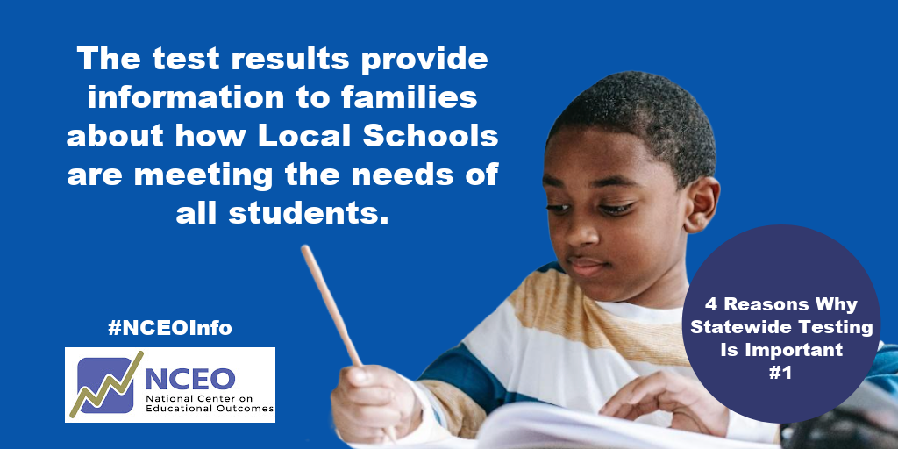

Day 2:
Why should your child participate in #StateTesting?

REASON 2: State tests allow each child to show their learning and their progress toward meeting state academic standards.

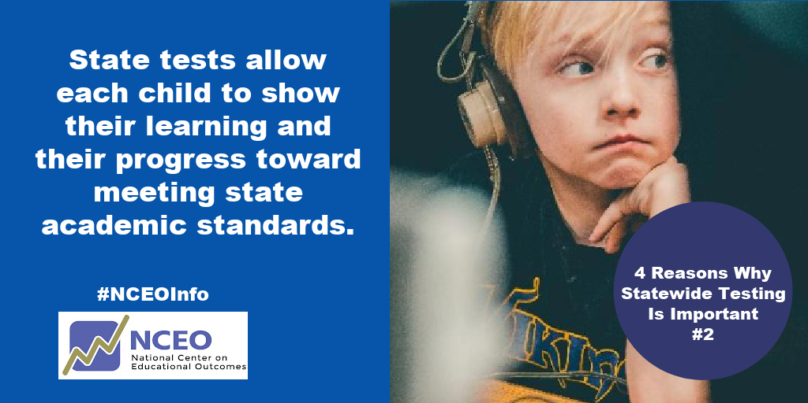

Day 3:
#StateTesting is important for #AllStudents.

REASON 3: #StateTest results let parents know how well your child’s school is teaching #AllStudents.

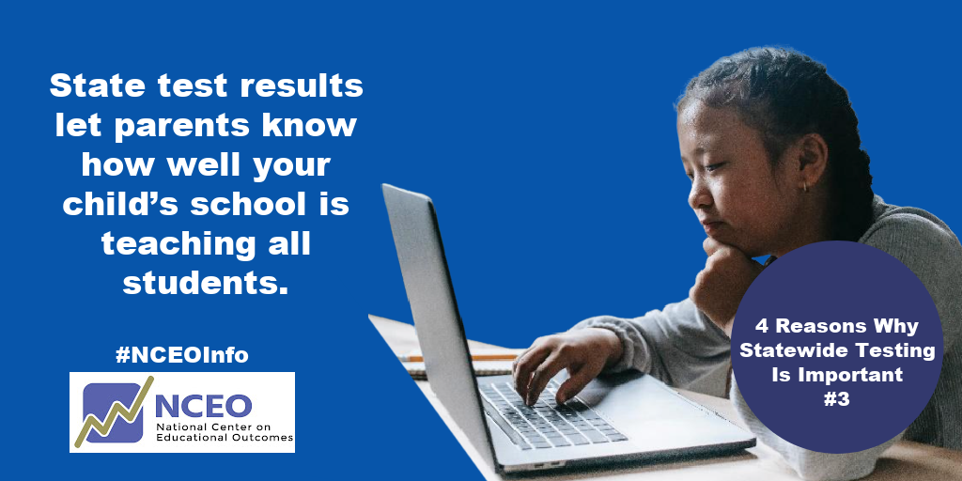

Day 4:
#StateTesting participation benefits #FamilyEngagement.
REASON 4: #StateTesting results can help families check their child's progress toward completing high school and assessing their readiness for a career or college pathway.

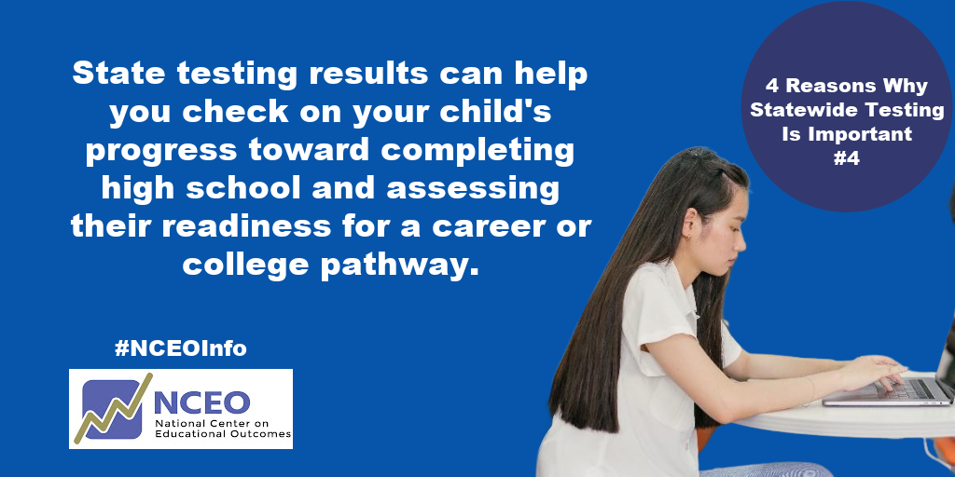

5-day series on the important role parents and families play in helping their student mentally prepare for state tests

DAY 1:
#FamilyInvolvement is crucial in helping students mentally prepare for #StateTests. Join the Testing 5 Days Challenge to learn five practical suggestions for supporting your child during testing. Stay tuned!

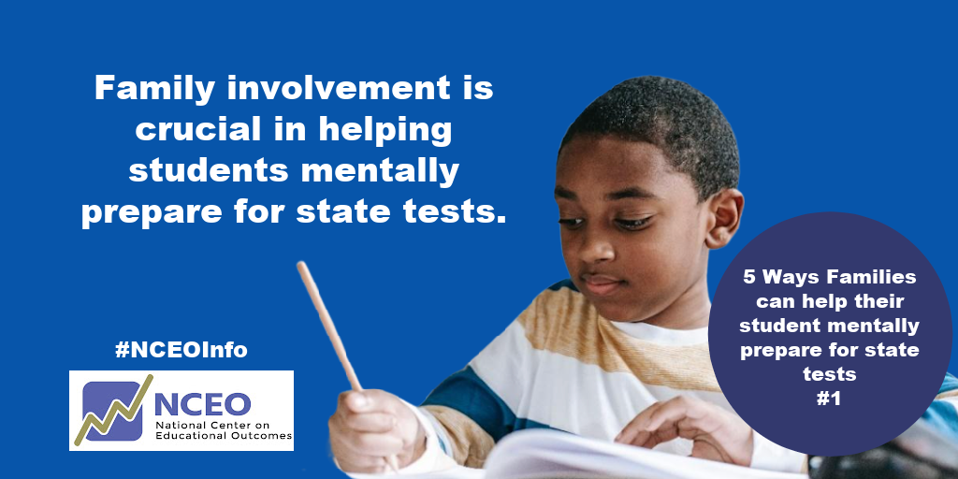

DAY 2:
#StateTests are coming. Talk with your child about #Testing to be sure they understand why they are participating and how they can do their best.

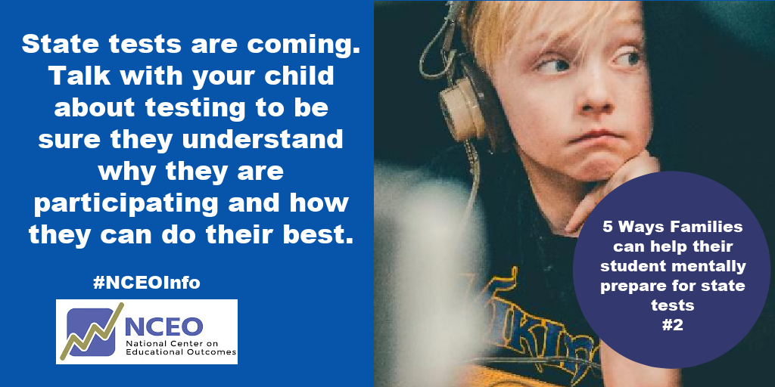

DAY 3:
#FamilyInvolvement #PositiveLanguage about #StateTests can help your child do their best. #PositiveSelfTalk guidance helps too! (e.g., I can do my best; mistakes are okay).

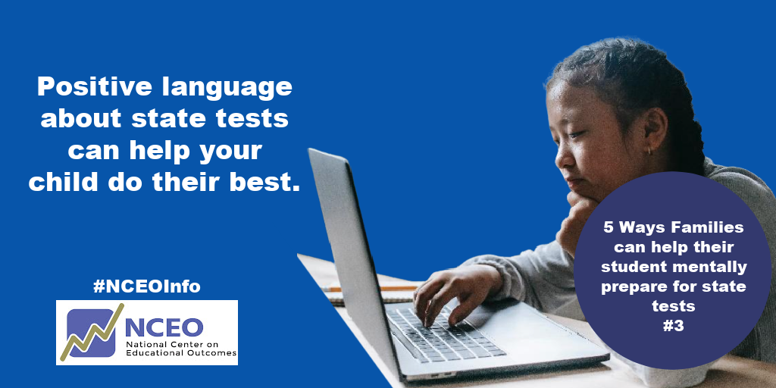

DAY 4:
#FamilyInvolvement #TestingAnxiety is the reality for many kids. Help them practice #StressReducing and #CalmingStrategies (breathing exercises, stretching, and #PositiveSelfTalk). #StateTests

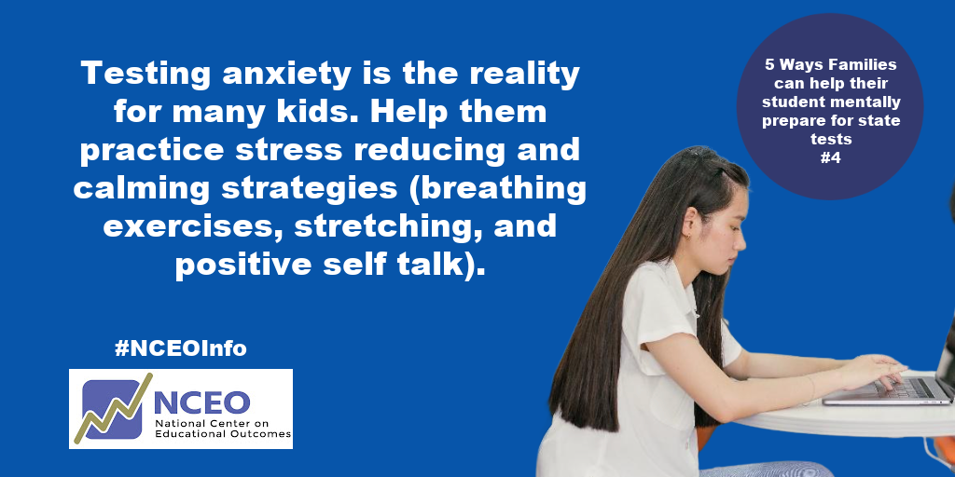

DAY 5:
Help your child be prepared for #StateTests by talking about #Testing as a regular part of learning. Your #ParentExperiences with #SchoolTesting can help.

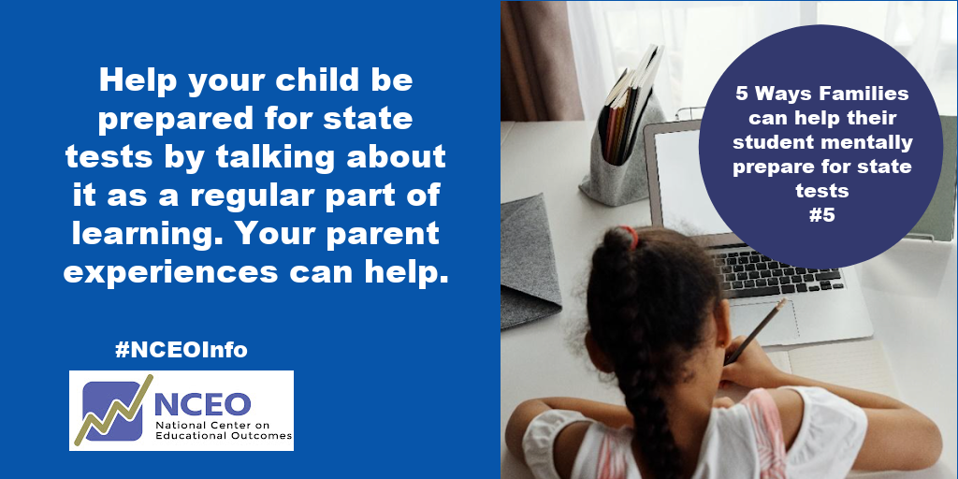

Sample Royalty Free Photos to Use in Social Media Posts
(Downloadable at: https://nceo.umn.edu/docs/OnlinePubs/ParticipationCommunicationToolkit/CommunicationToolkitPhotos.docx)

Family Letter

To increase engagement and build understanding about state testing participation with families, districts and schools can share a letter with families about state testing. The letter can be translated into multiple languages and distributed in multiple ways, including traditional mail, email, text message, on school portals and websites, or via social media, as well as through PTA/PTOs. State education agencies can provide a draft letter that district and school leaders can tailor and share with families.

*********
Dear Parent/Guardian,

Each year, students in grade(s) [INSERT GRADE LEVEL] participate in state testing known as [INSERT TEST NAME].

We will conduct the [INSERT TEST NAME] this spring between [START DATE] and [END DATE].

Why is State Testing Important?
[TEST NAME] helps inform decisions on how we allocate resources, make programming decisions for our students, and deliver instructional supports to all students.

[TEST NAME] is only one way to measure student learning and should be combined with other important factors, including classwork, quizzes, report card grades, and teacher feedback, to give families and teachers a more complete picture of how students are doing. It is not meant to tell the full story about a student, but rather to show how well they met the grade-level expectations in English language arts, math, and science.

For more information about how the test will be given, and the specific dates and times when your child will take the test in each subject, see [INSERT LINK].

If you have questions, please contact [NAME] at [PHONE NUMBER] or at [EMAIL ADDRESS]

Thank you,
[SUPERINTENDENT/PRINCIPAL]

One-Page “ready-to-go” Flyers
The following resources provide useful information about state testing for a range of education partners, including teachers, policymakers, families, and students. The purpose of these flyers is to provide concise resources about why it is so important that all students participate in state testing. It also provides strategies to reduce student test anxiety. These flyers can be displayed during state testing windows, shared during parent-teacher meetings, and distributed during school events. For those who desire to customize the flyers, longer fully customizable versions of the flyers are available in Appendix A.

Teacher One-Page “ready-to-go” Flyer
https://nceo.umn.edu/docs/OnlinePubs/ParticipationCommunicationToolkit/EducatorFlyerOnePage.pdf
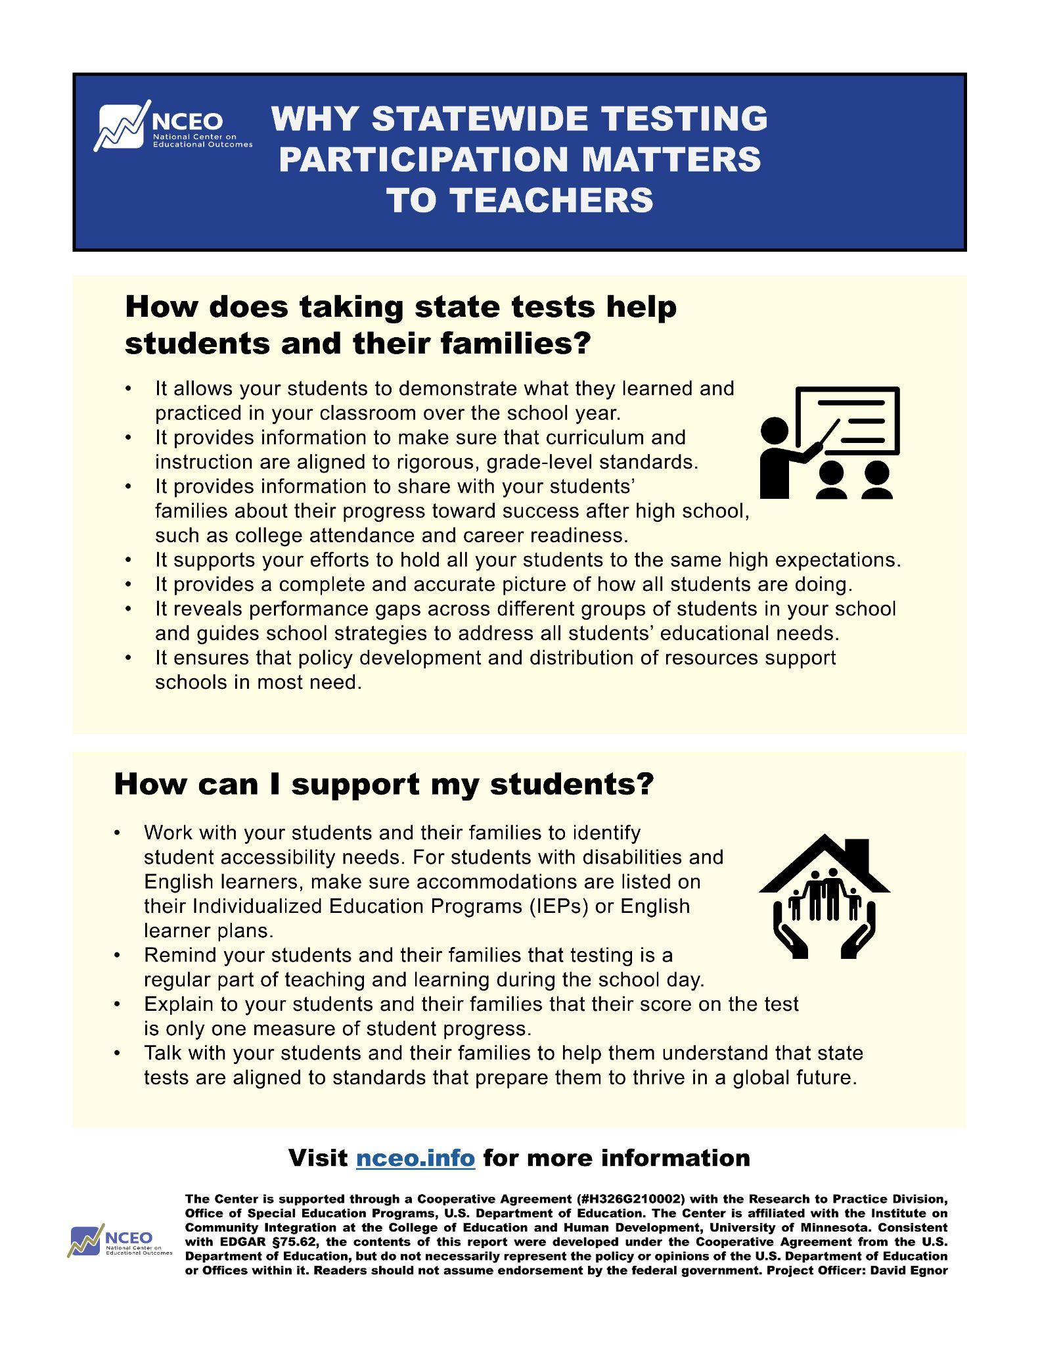

Policymaker One-Page “ready-to-go” Flyer
https://nceo.umn.edu/docs/OnlinePubs/ParticipationCommunicationToolkit/PolicymakersFlyerOnePage.pdf
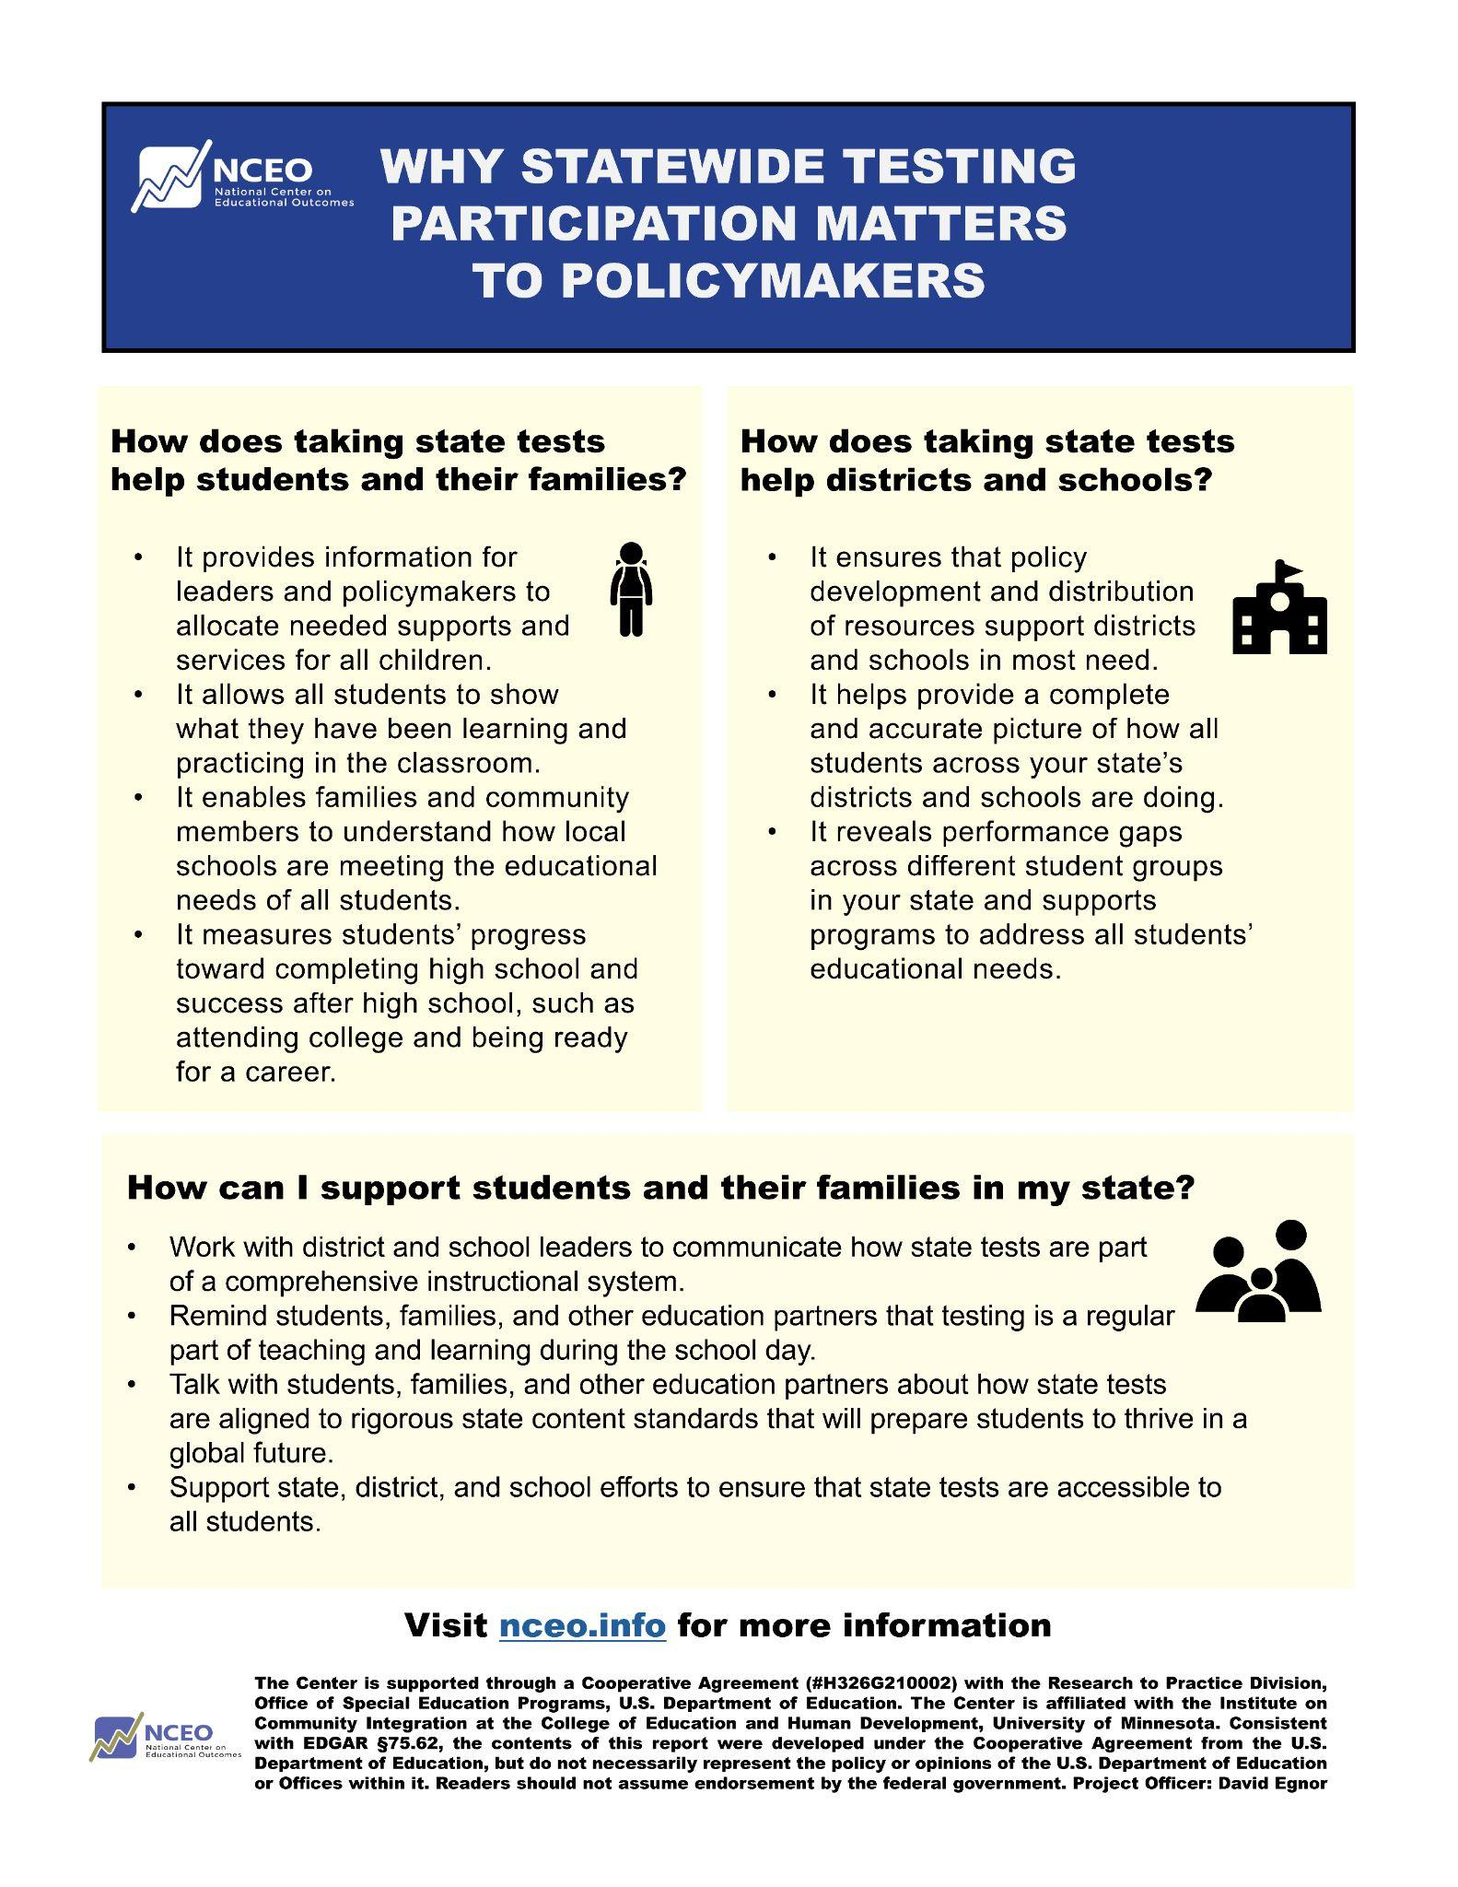

Families One-Page “ready-to-go” Flyer
https://nceo.umn.edu/docs/OnlinePubs/ParticipationCommunicationToolkit/FamilyFlyerOnePage.pdf
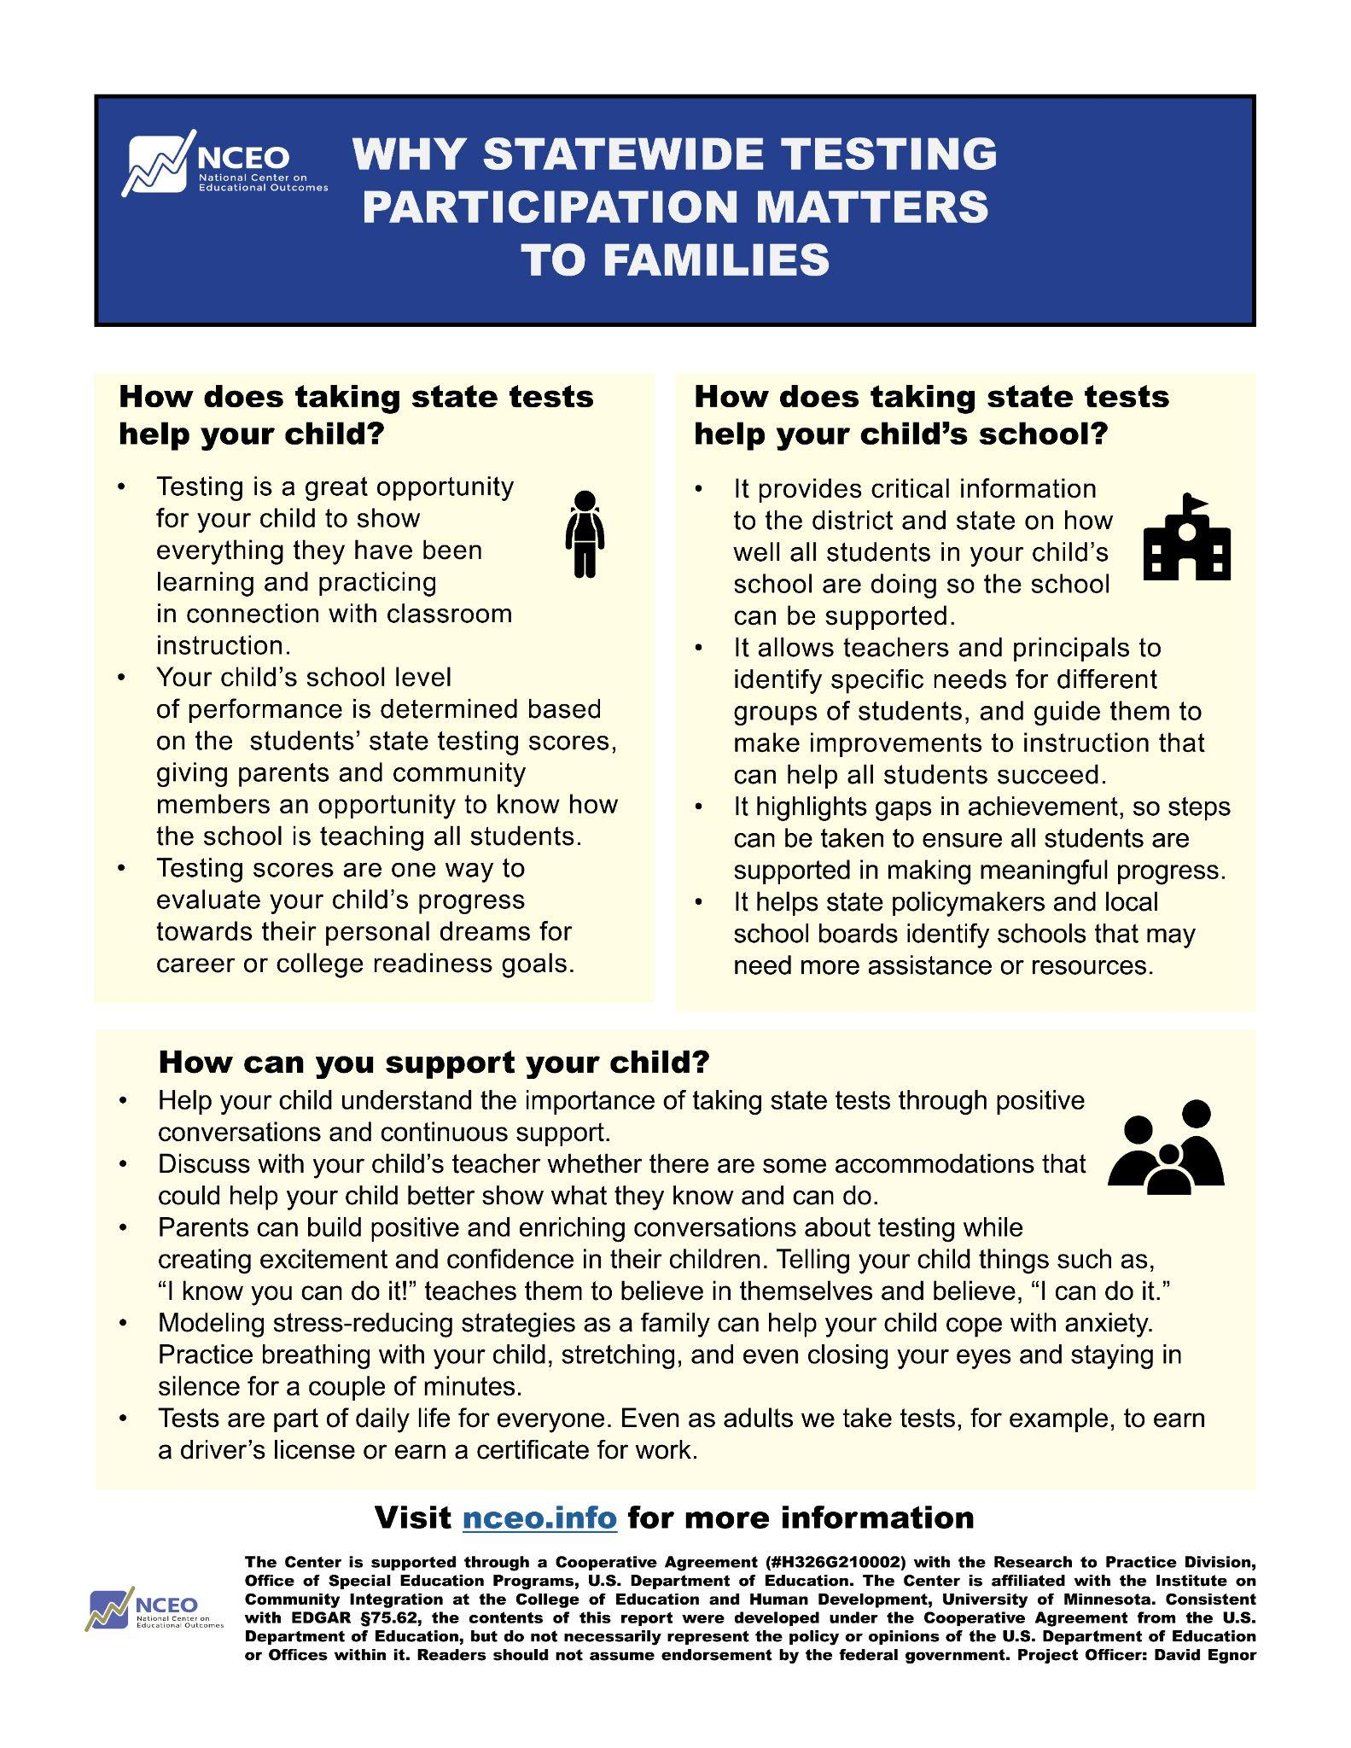

Students One-Page “ready-to-go” Flyer
https://nceo.umn.edu/docs/OnlinePubs/ParticipationCommunicationToolkit/StudentsFlyerOnePage.pdf
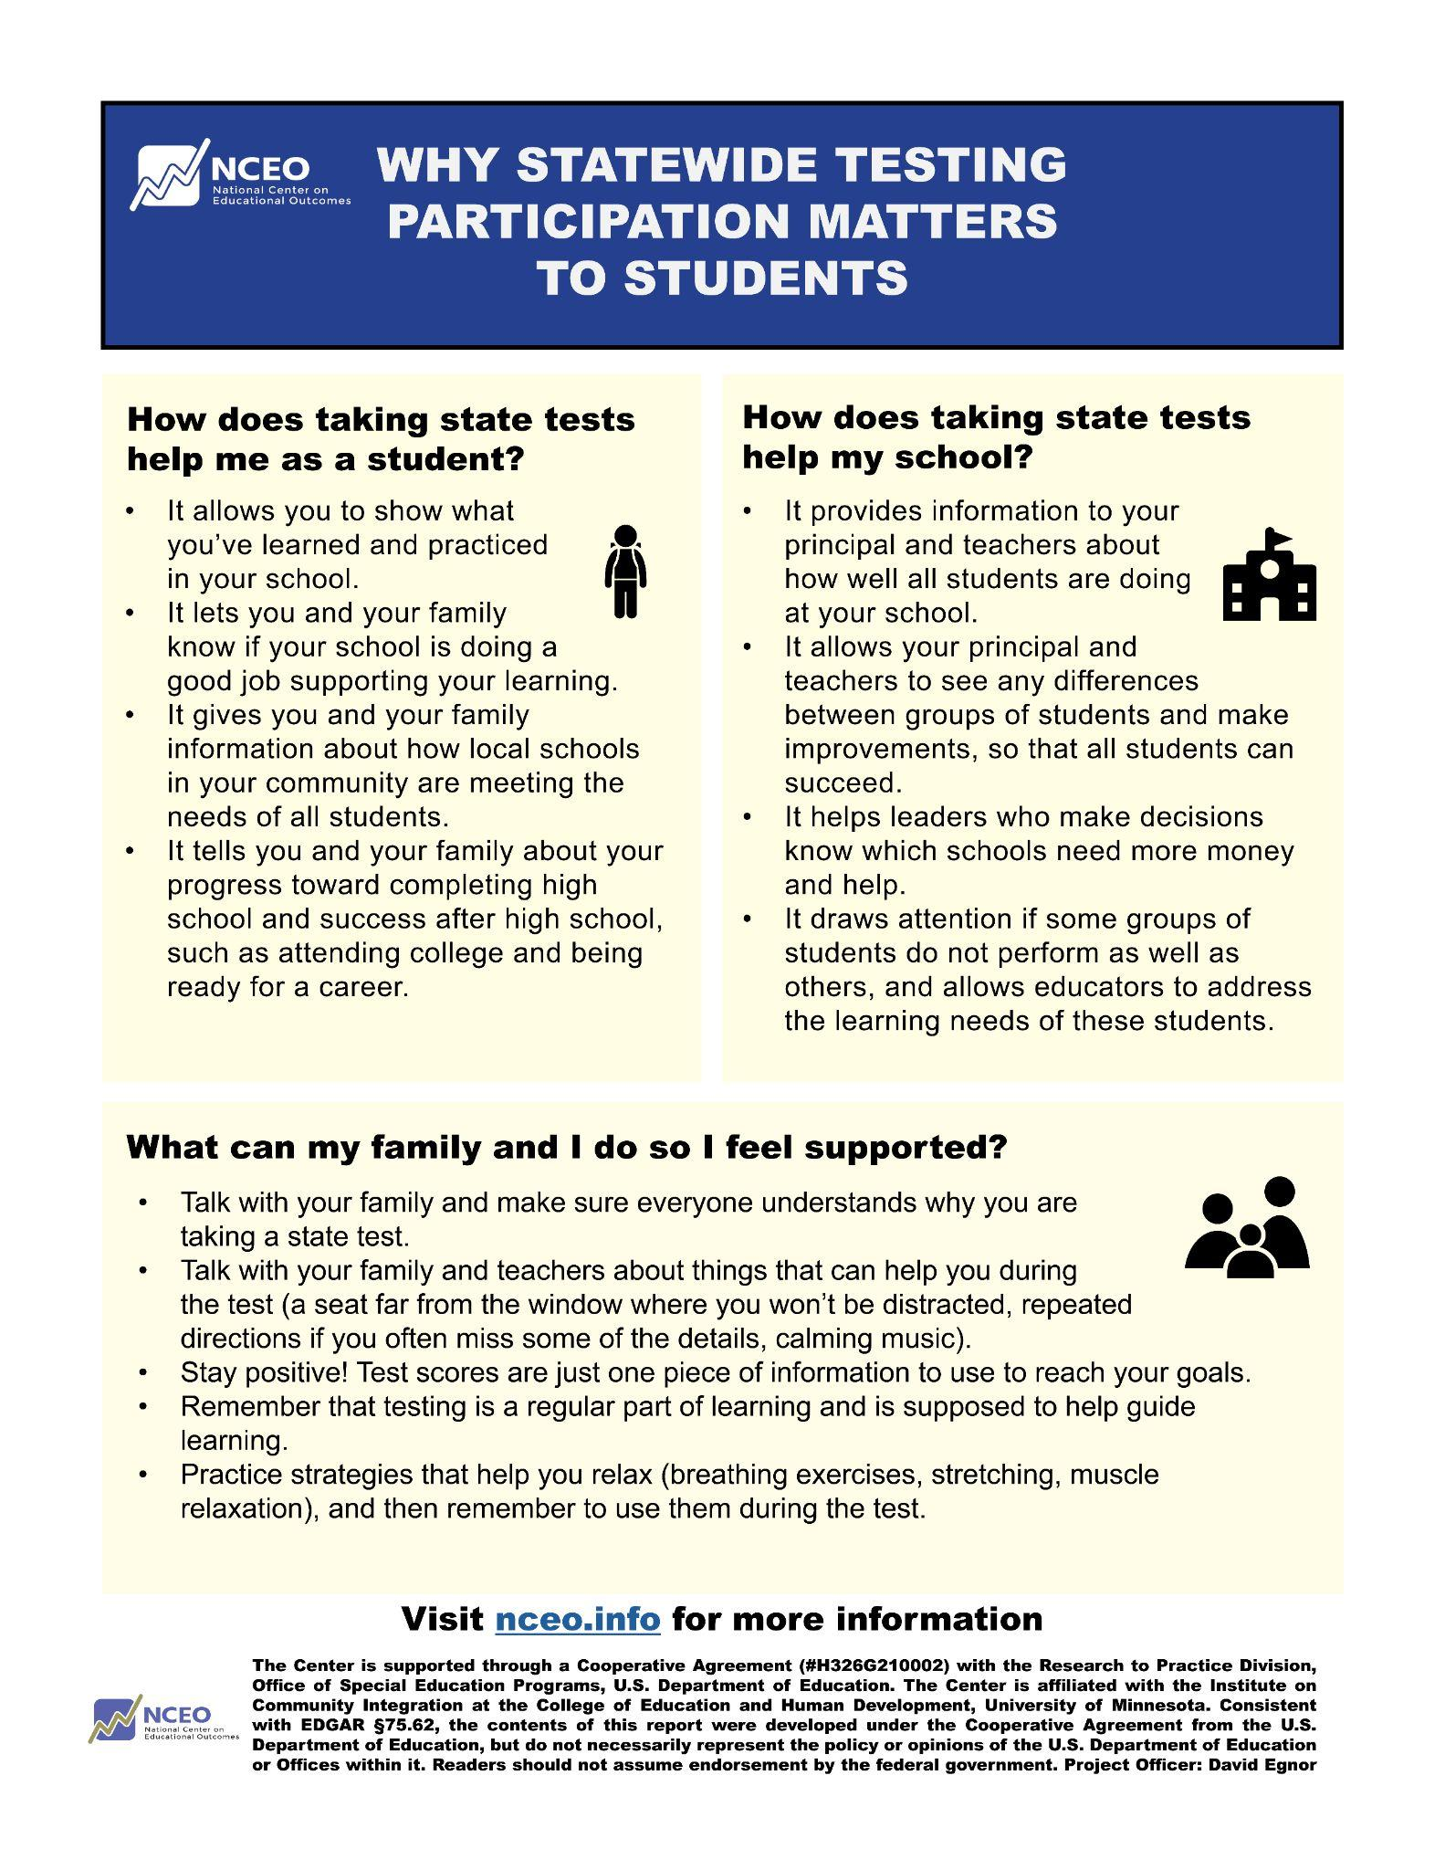

IEP Team One-Page Discussion Guide

For students with disabilities, many test participation decisions are made during IEP team meetings. The following discussion guide for IEP teams is designed to provide information about the different test options for students with disabilities, and the implications of those decisions. This resource also explains why it is so important that students with disabilities participate in state testing.

https://nceo.umn.edu/docs/OnlinePubs/ParticipationCommunicationToolkit/IEPteamFlyerOnePage.pdf

For those who desire to customize the flyers, a longer fully customizable Word version of the discussion guide is available in Appendix A.

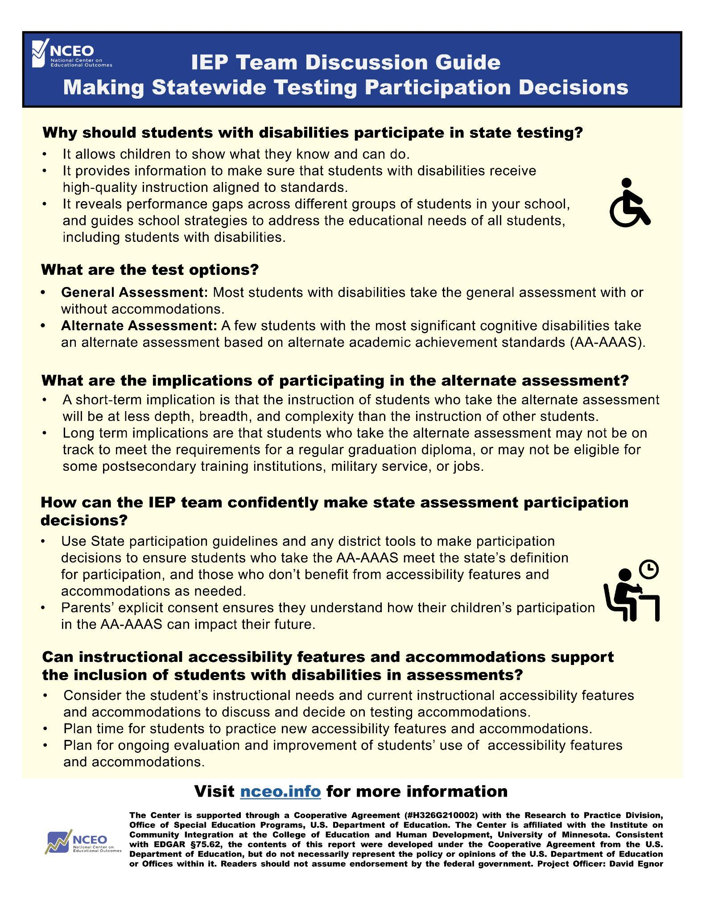

Slide Presentation

This customizable slide presentation is designed to support the needs of state education agency staff, and district and school administrators for brief but substantive information district and school administrators can use when communicating with educators, policymakers, families, and other stakeholders about why it is so important that students participate in state assessments. In addition to serving as an information resource for administrators, it may be used for in-person or webinar trainings for educators, and as a handout for educators and parents. The slides may be customized for each state (see https://nceo.umn.edu/docs/OnlinePubs/ParticipationCommunicationToolkit/SlideDeckTemplate.pptx to access the actual PowerPoint slides).

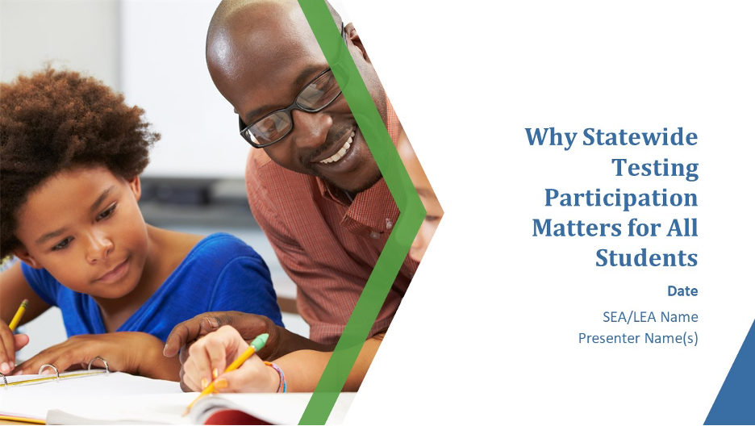

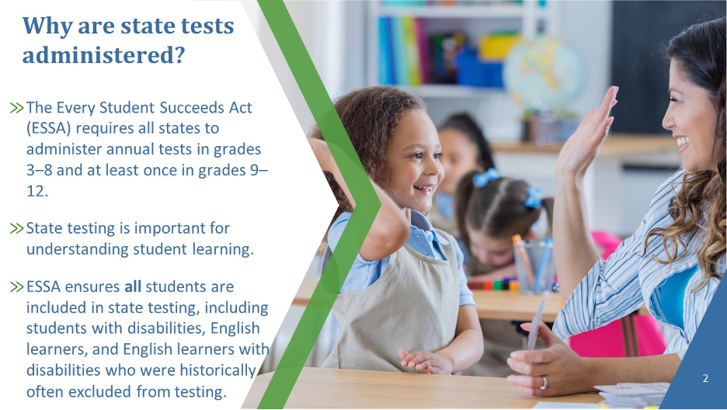

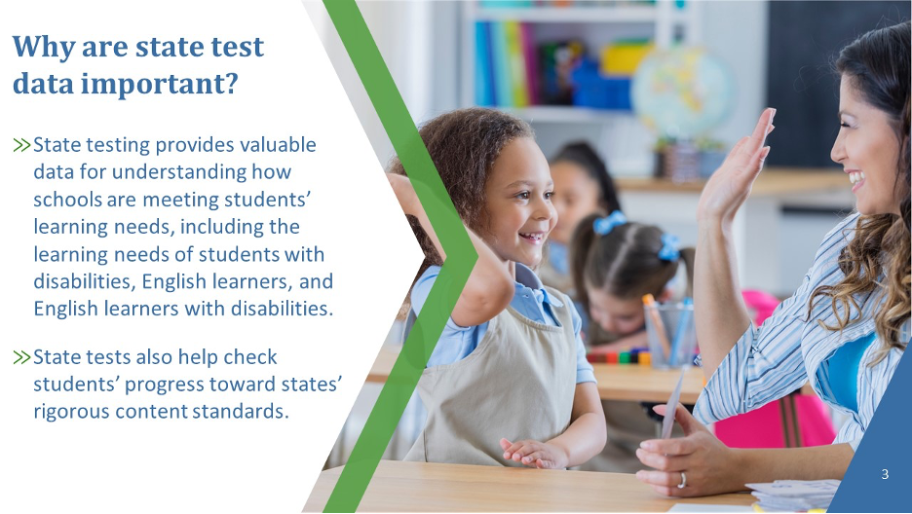

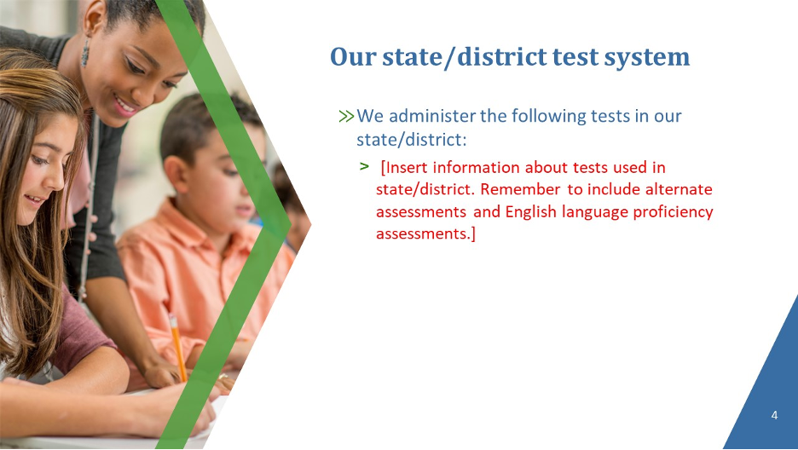

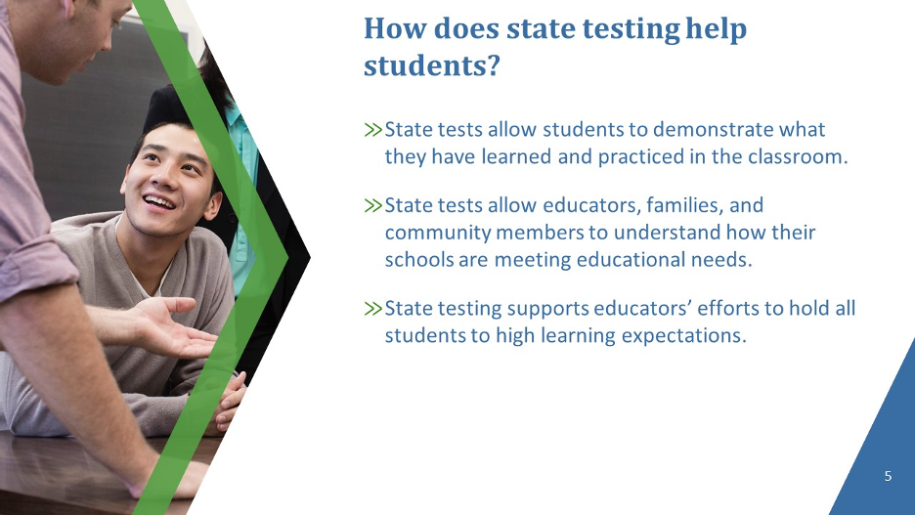

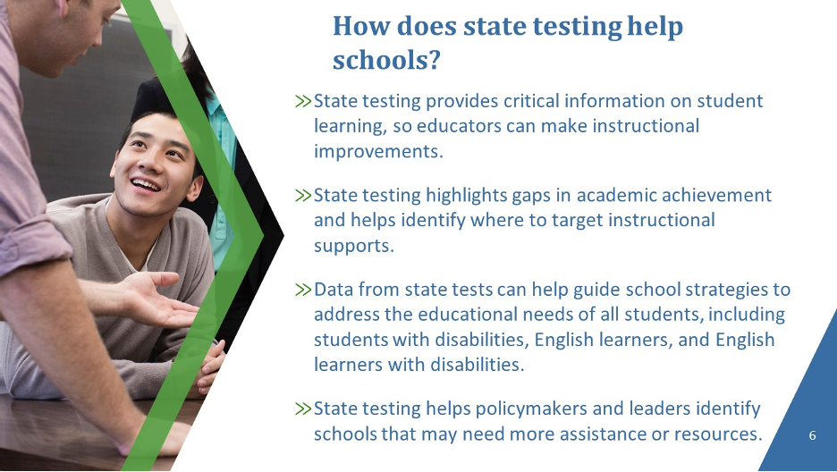

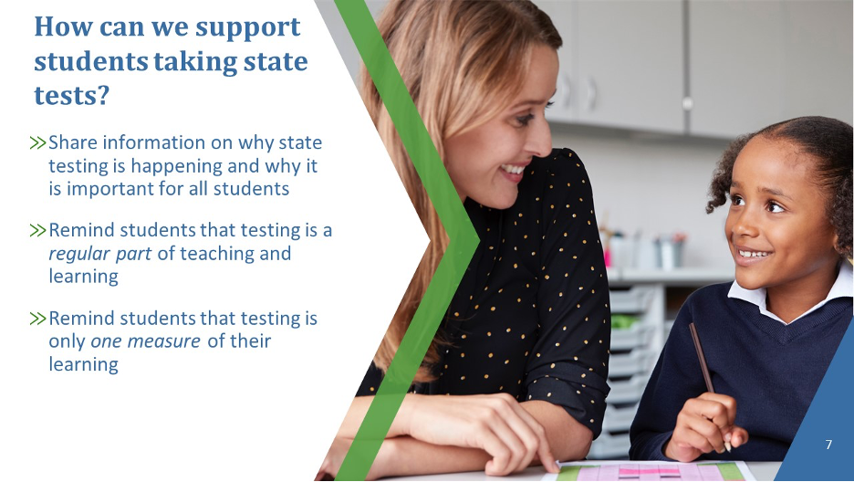

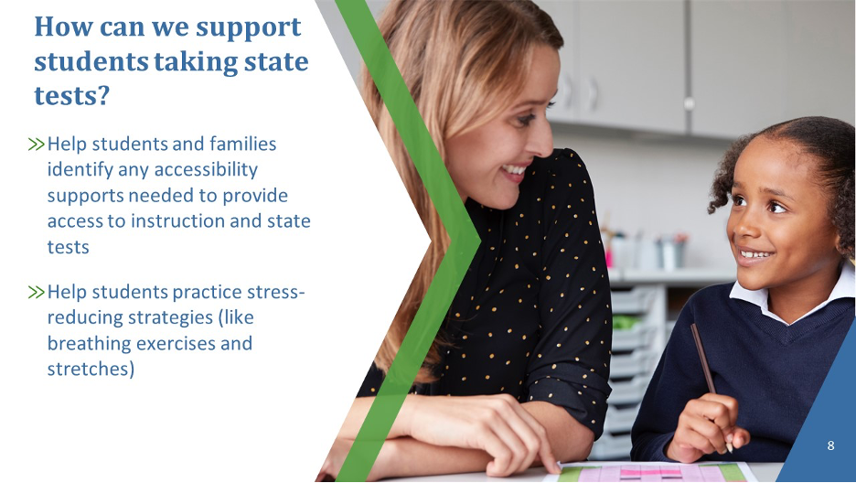

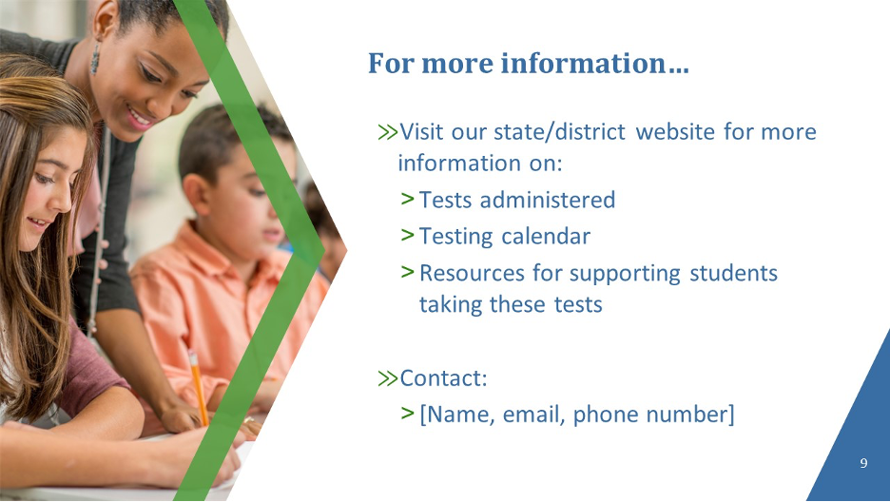

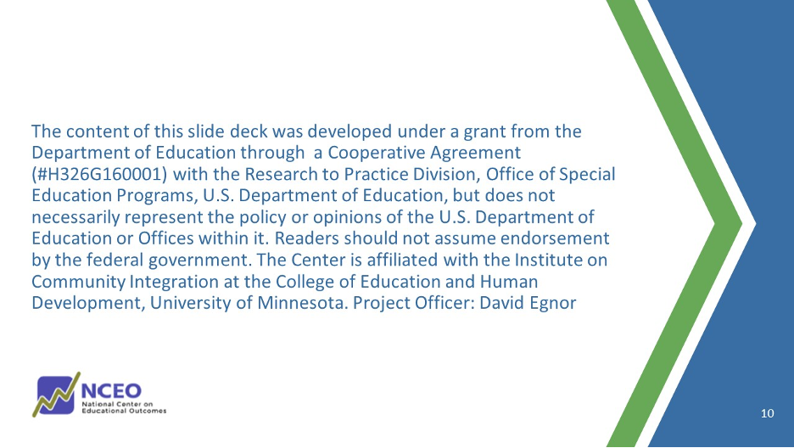

Appendix A: Customizable Flyers

The following customizable resources provide useful information about state testing for a range of education partners, including teachers, policymakers, families, and students. The purpose of these flyers is to provide concise resources about why it is so important that all students participate in state testing that can be customized with local graphics and contact information. It also provides strategies to reduce student test anxiety. These flyers can be displayed during state testing windows, shared during parent-teacher meetings, and distributed during school events.

*********

National Center on Educational Outcomes
www.nceo.info
NCEO is supported through a cooperative agreement (H326G160001) between the University of Minnesota, National Center on Educational Outcomes (NCEO) (#H326G160001) and the U.S. Department of Education, Office of Special Education and Rehabilitative Services (OSERS), Office of Special Education Programs. The materials do not necessarily reflect the position or policy of the U.S. Department of Education or Offices within it. Project Officer: David Egnor

Teacher Customizable Flyer

Downloadable at: https://nceo.umn.edu/docs/OnlinePubs/ParticipationCommunicationToolkit/EducatorFlyer.docx

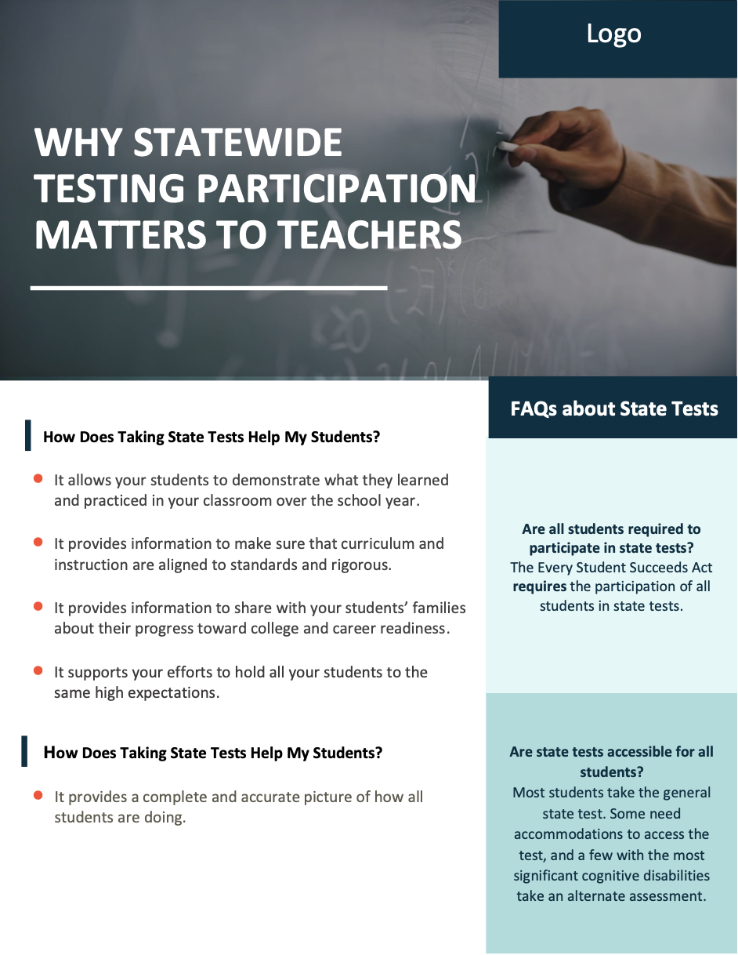

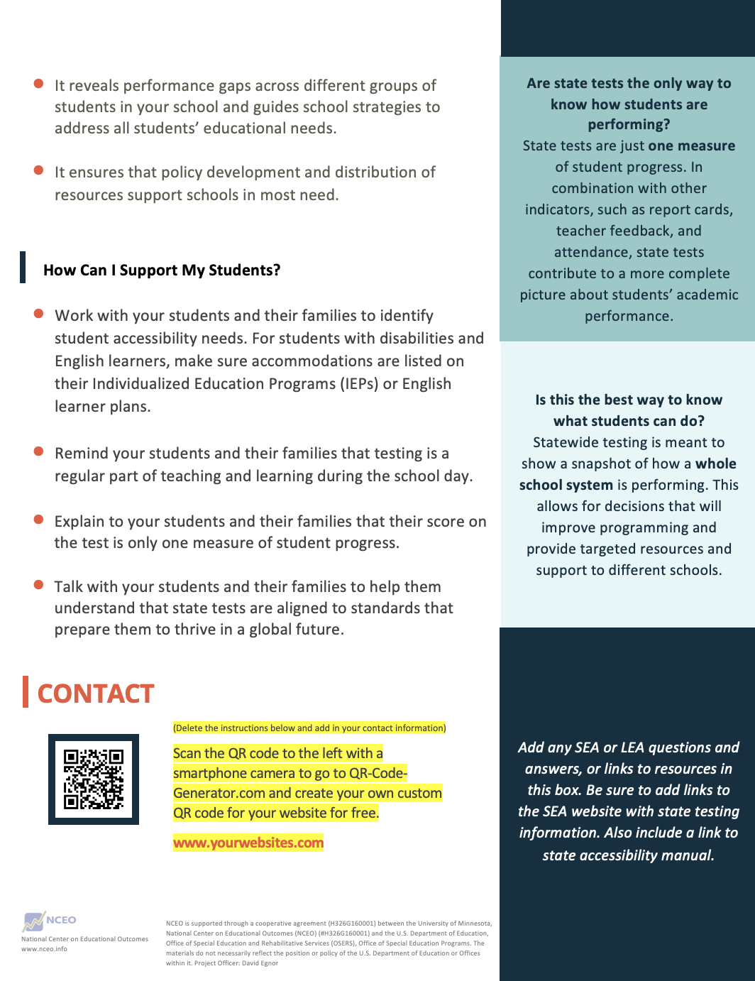

Policymaker Customizable Flyer

Downloadable at: https://nceo.umn.edu/docs/OnlinePubs/ParticipationCommunicationToolkit/PolicymakerFlyer.docx

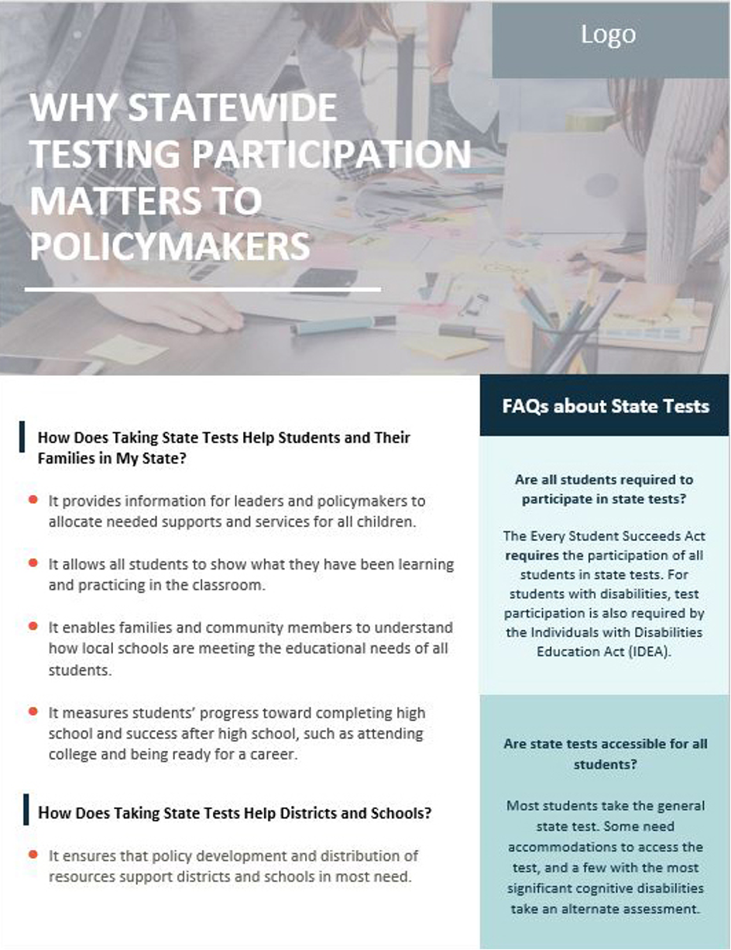

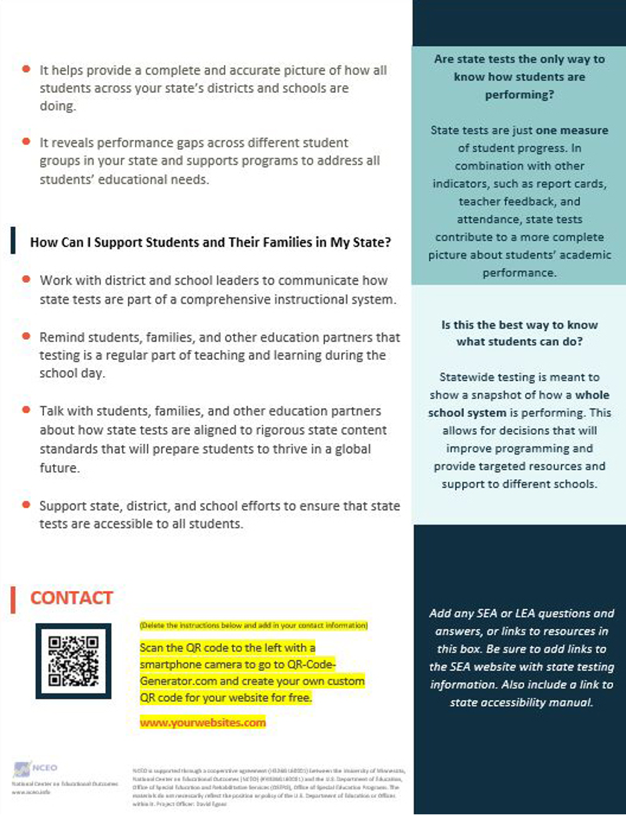

Parent Customizable Flyer

Downloadable at:
https://nceo.umn.edu/docs/OnlinePubs/ParticipationCommunicationToolkit/FamilyFlyer.docx

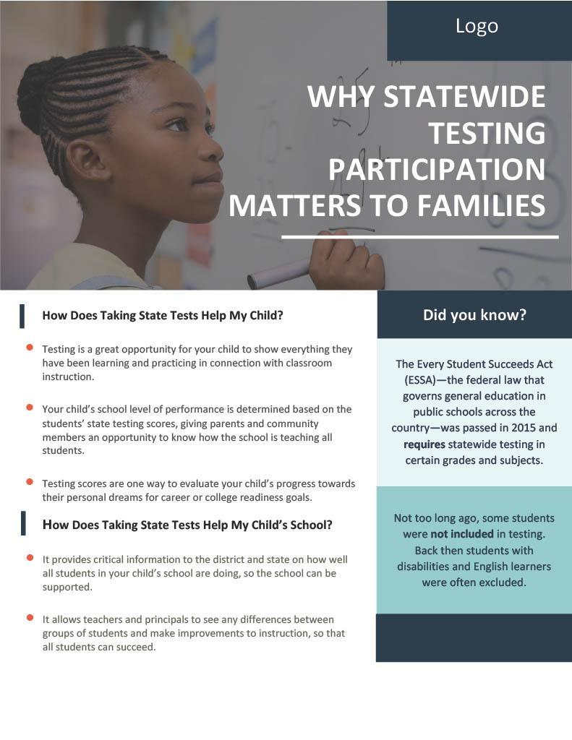

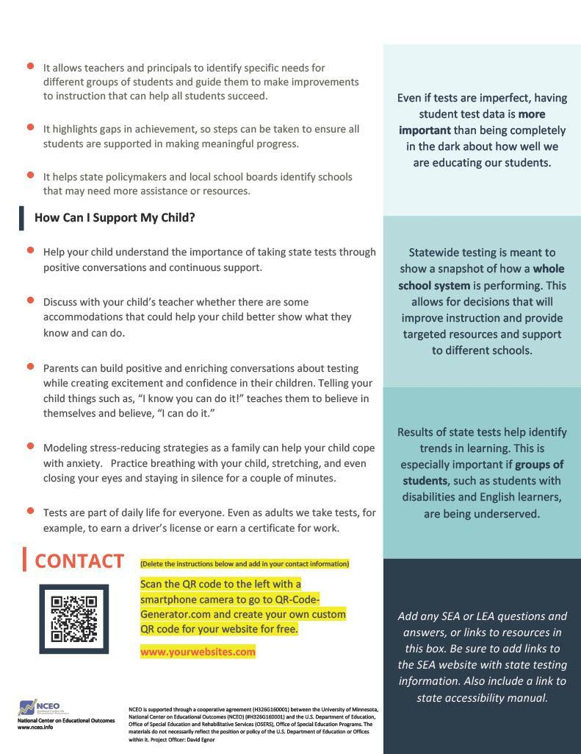

Student Customizable Flyer

Downloadable at: https://nceo.umn.edu/docs/OnlinePubs/ParticipationCommunicationToolkit/StudentFlyer.docx

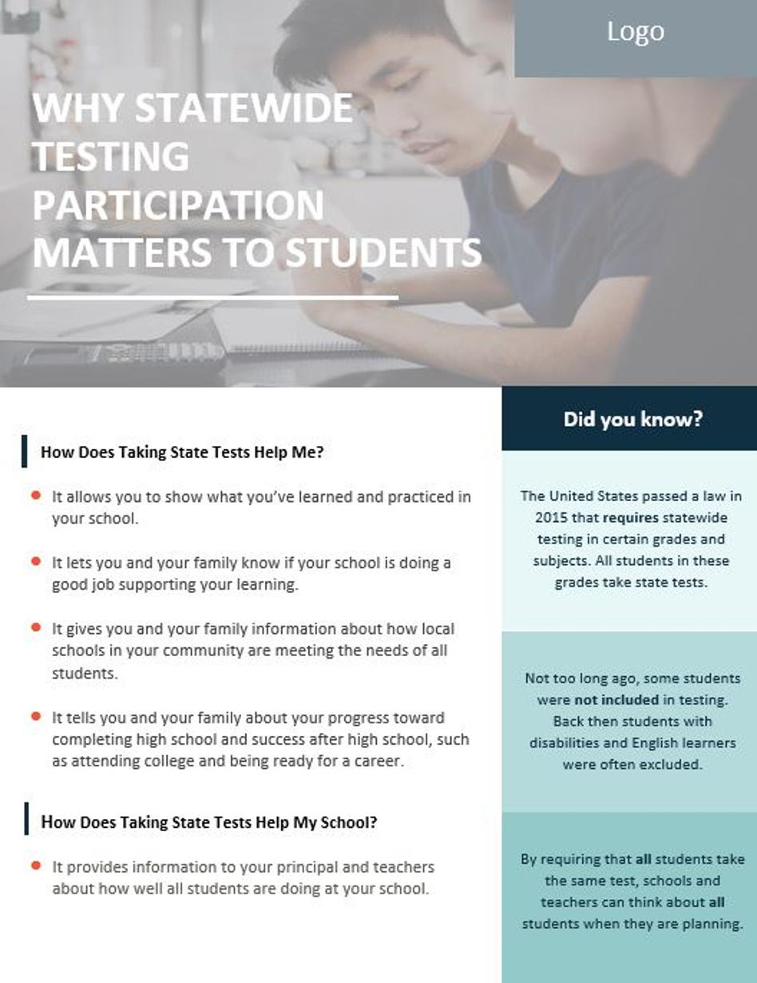

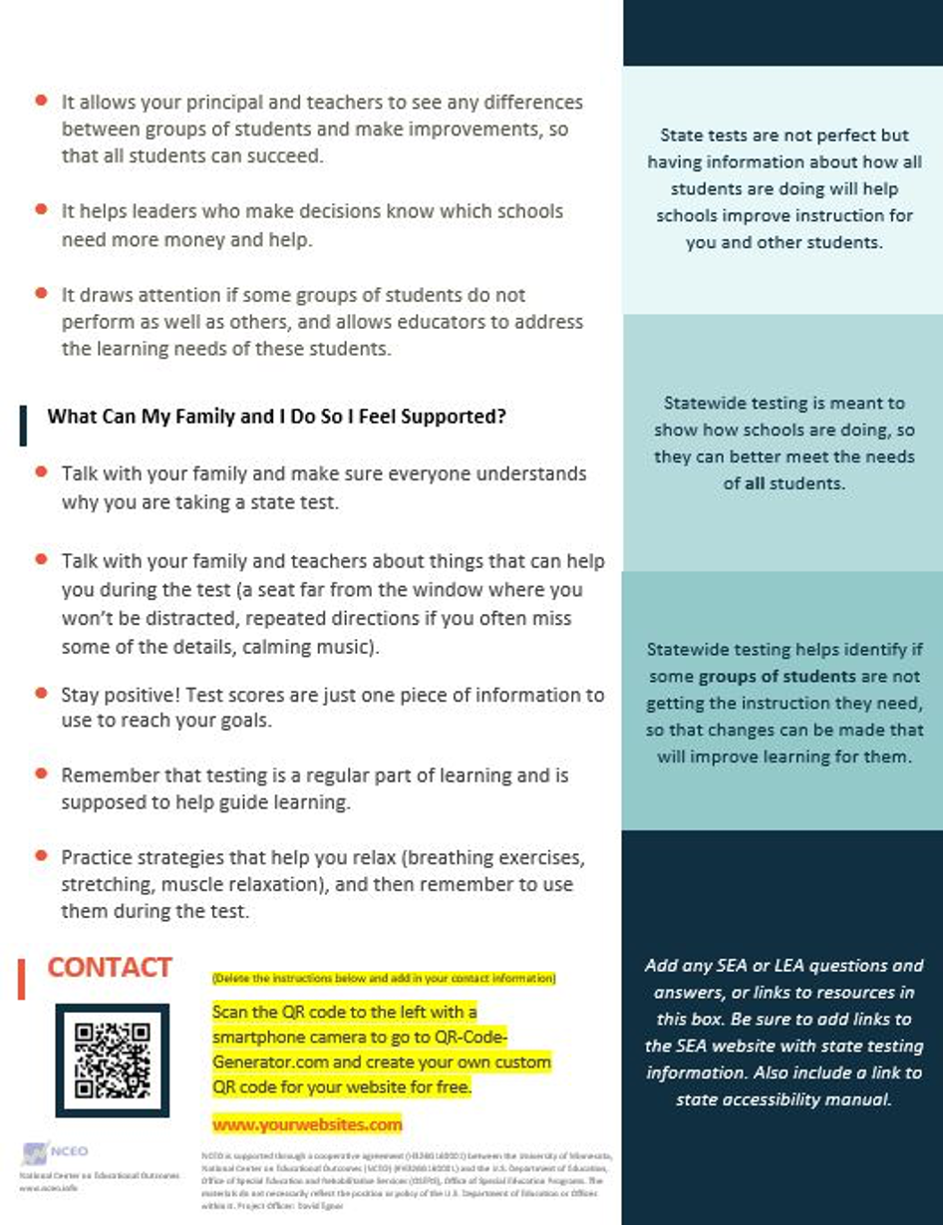

IEP Team Customizable Discussion Guide

Downloadable at: https://nceo.umn.edu/docs/OnlinePubs/ParticipationCommunicationToolkit/IEPteamDiscussionGuide.docx
